PortSwigger Lab POC - 09-username-enumeration-account-lock-v2

Lab 9 — Username enumeration via account lock

Step 1 — Login with random credentials
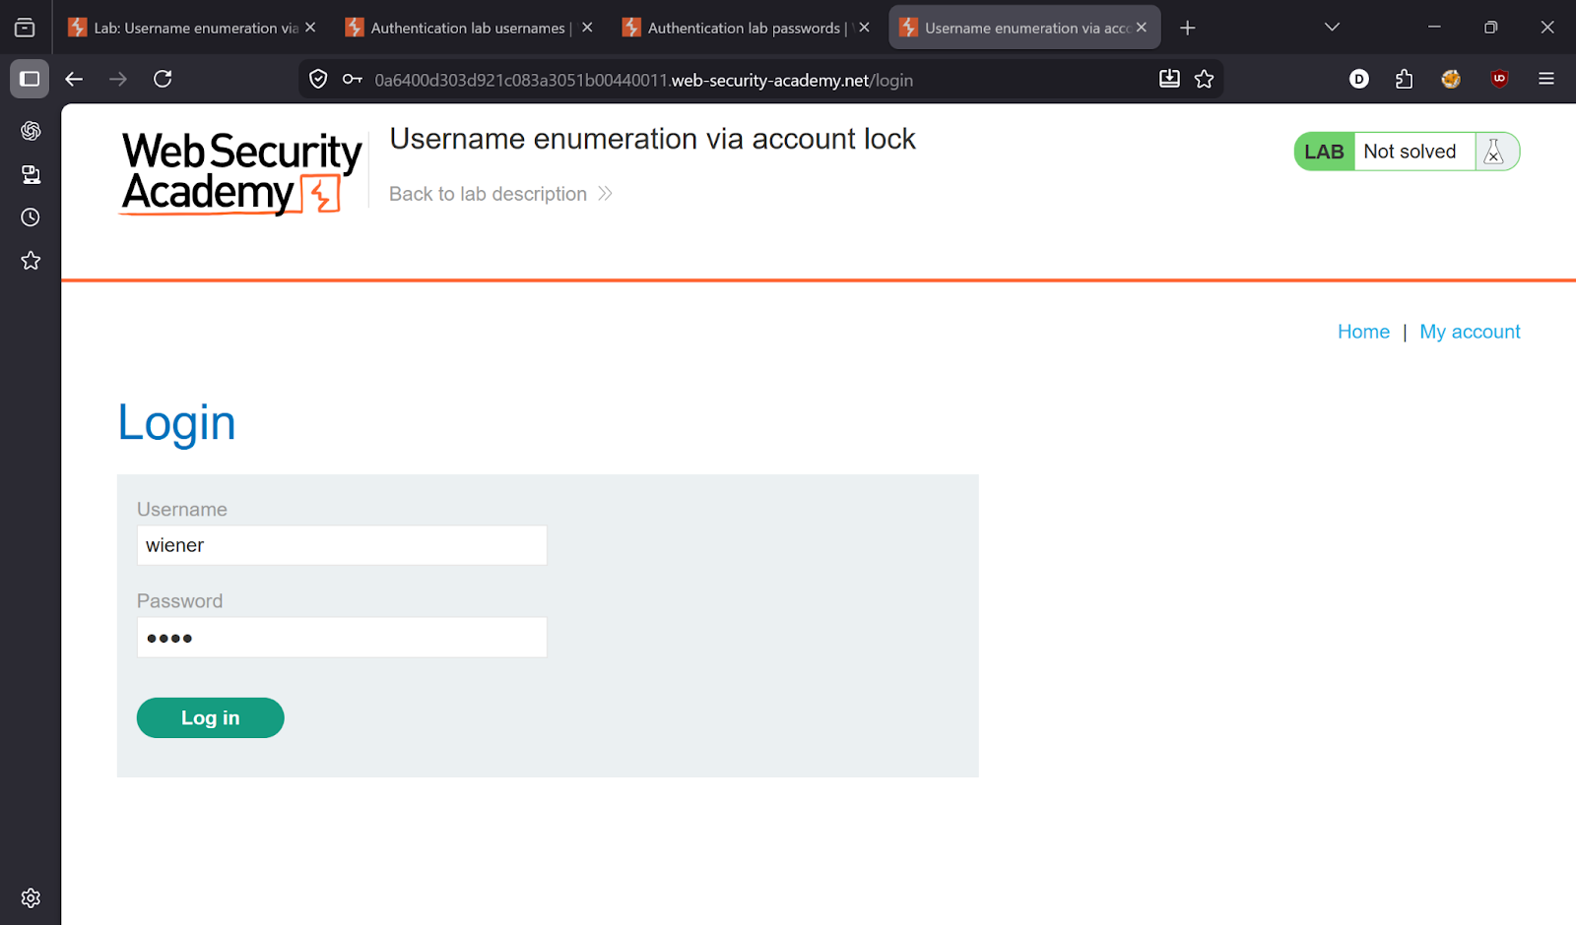

Step 2 — Intercept and send to Intruder
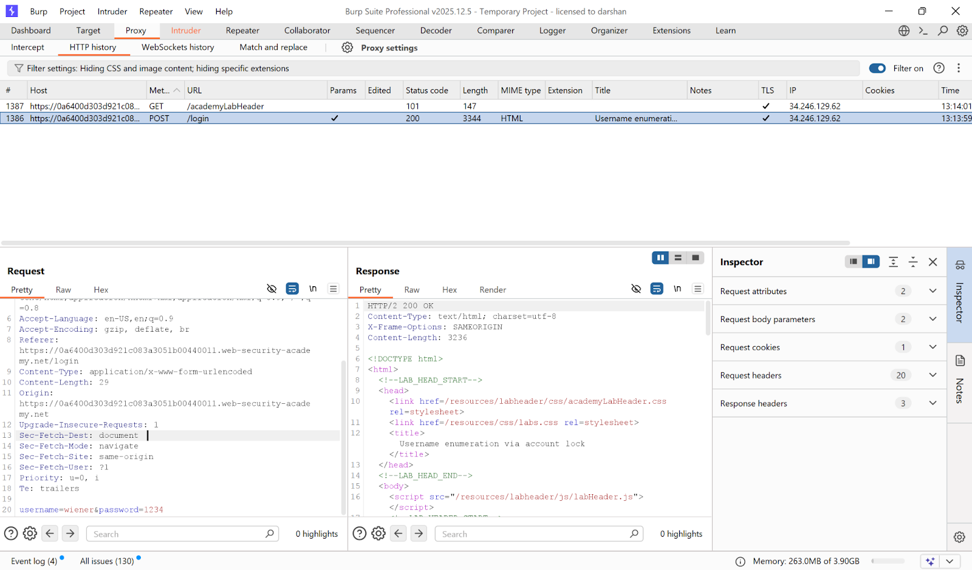

Step 3 — Cluster Bomb attack
Attack type: **Cluster Bomb** — payload on both username and password.

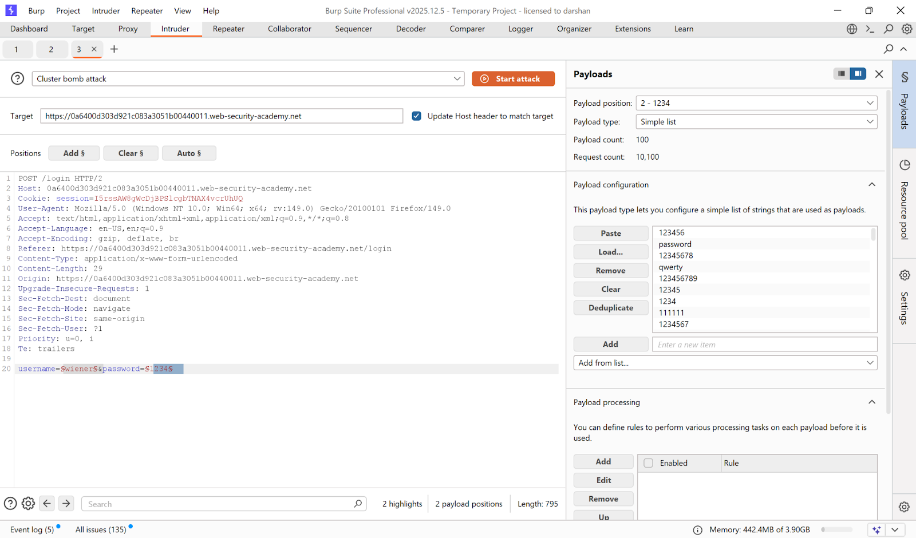
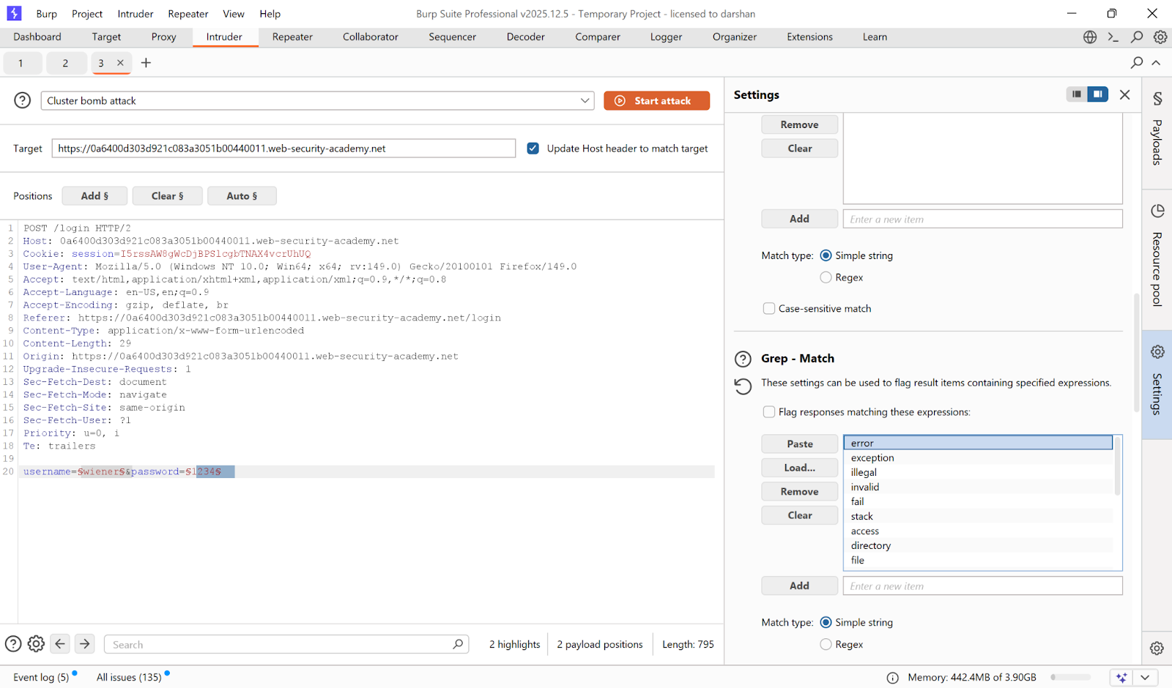

Step 4 — Find locked account = valid username
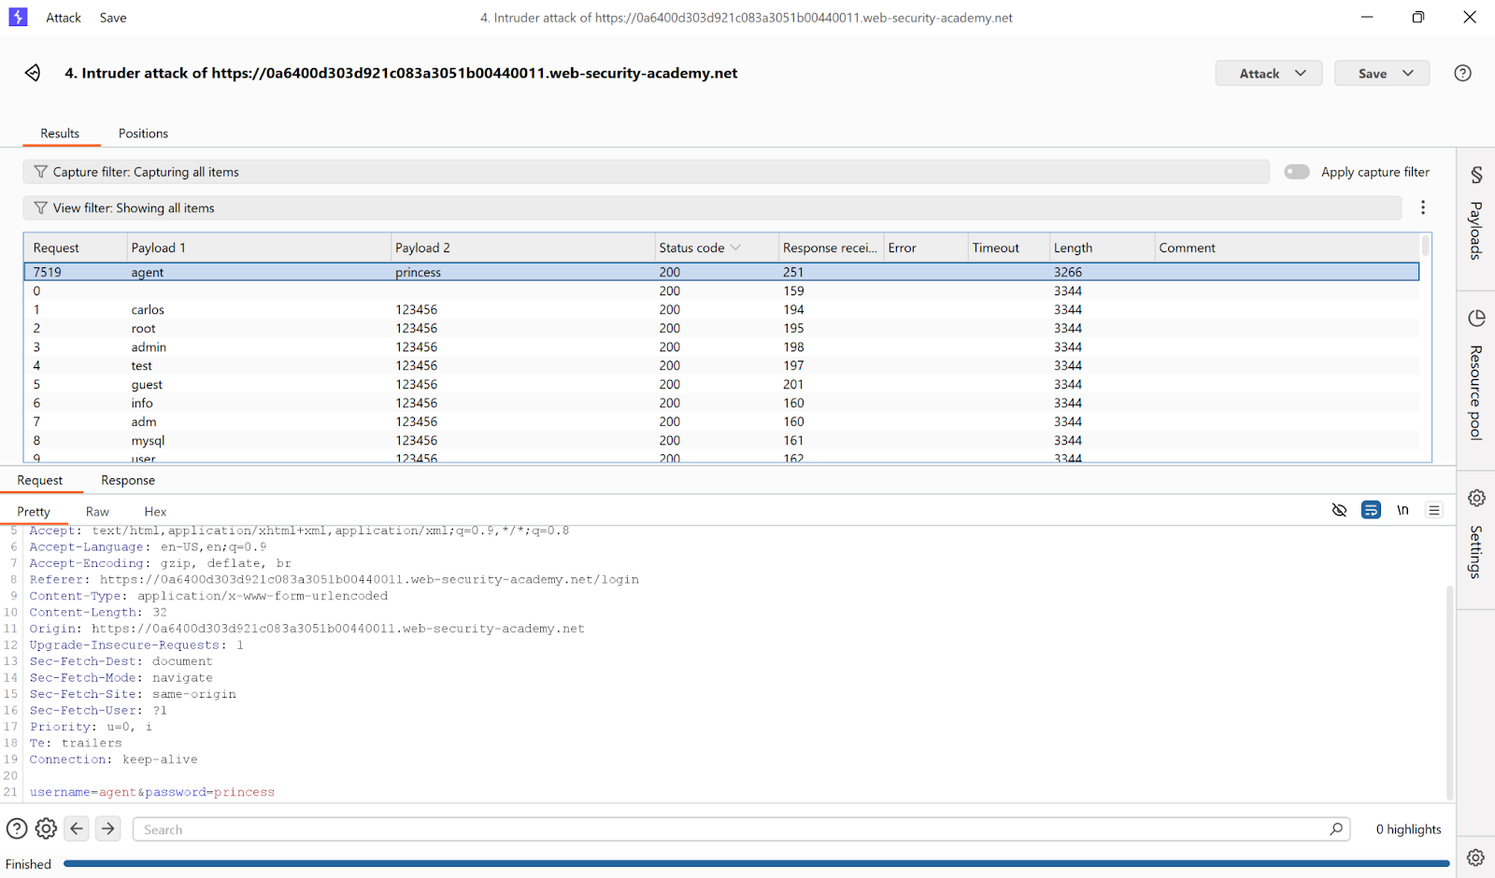

Step 5 — Login as victim
- **Username:** `agent`
- **Password:** `princess`

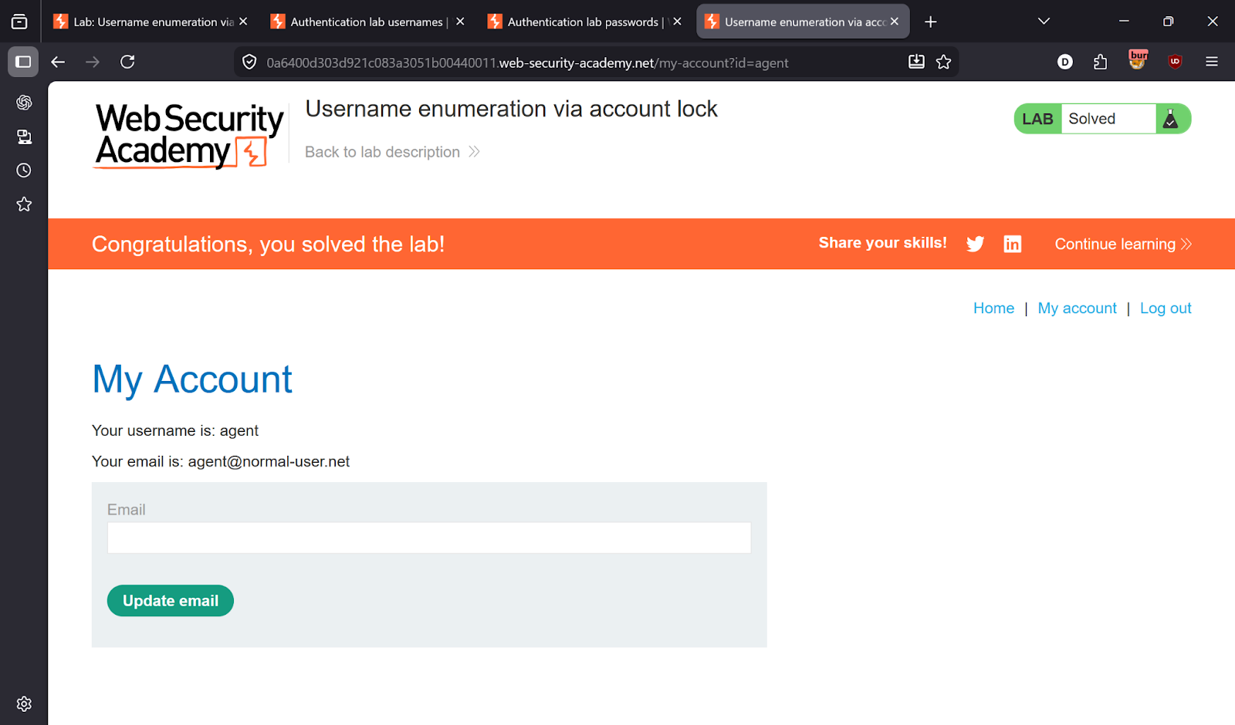

---

✅ Result
Lab solved!

